[bharathi](https://bharathi2105.blogspot.com/?m=1)



**Bharathiicecreamshop**

[October11,2023](https://bharathi2105.blogspot.com/2023/10/bharathi-ice-cream-shop.html?m=1)

ASSIGNMENT LINK :https://bharathi2105.blogspot.com/2023/10/bharathi-ice-cream-shop.html?m=1

Icecreamisafrozendesserttypicallymadefrommilkorcreamthathasbeenﬂavouredwithasweetener,eithersugaroranalternative,andaspice,suchascocoaorvanilla,orwith fruit, such asstrawberriesor peaches. Food colouring issometimesadded in additionto stabilizers. The mixture is cooled below the freezing point of water and stirred toincorporate air spaces and prevent detectable ice crystals from forming. It can also bemadebywhiskingaﬂavouredcreambaseandliquidnitrogen together.Theresultisasmooth,semi-solidfoamthatissolidatverylowtemperatures(below2°Cor35°F).Itbecomesmoremalleableasitstemperatureincreases.Icecreamisacolloidalemulsionmadewithwater,ice,milkfat,milkprotein,sugarandair.Milkproteinssuchascasein andwhey protein present in ice cream are amphiphilic, can adsorb water and form micelleswhichwillcontributetoitsconsistency.Theproteinscontributetotheemulsiﬁcation,aeration andtexture.Sucrose,whichisadisaccharide,isusuallyusedasasweeteningagent.Lactose,whichissugarpresentinmilk,willcausefreezingpointdepression.greaterthan10%milkfat

6 to10% milk and non- fat milk solids: this component, alsoknown as the milk solids- not- fator serum solids, contains the proteins (caseins and whey proteins) and carbohydrates(lactose)foundinmilk

Itgenerallyalsohas:[65]

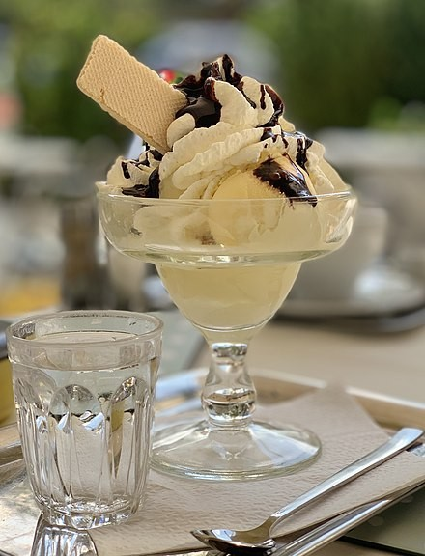

12 to16% sweeteners: usually a combination ofsucrose and glucose- based corn syrupsweeteners.Beforethedevelopmentofmodernrefrigeration,icecreamwasaluxuryreservedforspecialoccasions.Makingitwasquitelaborious;icewascutfromlakesandpondsduringthewinterandstoredinholesintheground,orinwood-frameorbrickicehouses,insulatedbystraw.Manyfarmersandplantationowners,includingU.S.PresidentsGeorgeWashingtonandThomasJefferson,cutandstorediceinthewinterforuseinthesummer.FredericTudorofBostonturnediceharvestingandshippingintoabigbusiness,cuttingiceinNewEnglandandshippingitaroundtheworld.

Icecreamwasmadebyhandinalargebowl placedinsideatubﬁlledwithiceandsalt.Thisiscalled thepot- freezer method.[58]French confectionersreﬁned thepot- freezer method,makingicecreaminasorbetière[fr](acoveredpail withahandleattachedtothelid).Inthepot- freezermethod,thetemperatureoftheingredientsisreduced bythemixtureofcrushediceandsalt.Thesaltwateriscooledbytheice,andtheactionofthesaltontheicecausesitto(partially)melt,absorbinglatentheatandbringingthemixturebelowthe

freezingpointofpurewater.Theimmersedcontainercanalsomakebetterthermalcontact

withthesaltywaterandicemixturethanitcouldwithicealone.

[Powered by Blogger](https://www.blogger.com/)[ReportAbuse](https://www.blogger.com/go/report-abuse)